Engineering Management
Student’s Name
Institutional Affiliation
Date of submission

Engineering Management
Report 1
Qn1. Leadership styles
Autocratic leadership is the method of management type where the top leader in an organization takes control of all operations programs and initiates all the rules and decision without consulting other members of the organization. This type of leadership allows topping leaders in an organization to formulate a decision on their control and do not involves other peoples input or advice. It is only applicable to in institutions that an immediate resolution. On other people views they believe in this leadership style as the best while to others they view it has dictatorship leadership skills. This leadership is useful at the point that an organization is facing an immediate and repetitive crisis as it allows the leader to react and solve any upcoming issue in an organization immediately (Holten and Brenner, 2015, pp10).
Laissez-faire leadership is where leaders in an organization give a chance to other group teams to formulate decisions. Specialists have found that this type of leadership leads to low production among the team members (Wellman and LePine 2017, pp205). It possesses less control from leaders where junior employees in an organization have the freedom to make a solution to solve the problem in an organization. This can appear to motivate team members in an organization, but it can result in poor performance.
Transformative leadership is whereby everybody in an organization is a leader and contributes to the operation of an institution. Its goal is to provide participation in bringing collaboration for the smooth running of an organization. This type of leadership is encouraged; it enables the growth of a company since it motivates employees to inspire them to determine what they are useful in.
Participant’s leadership is a style that works to promote teamwork among member's participants bring trust and commitment to attain complete system change. Finally, the leader makes the last decision; they reach the final decision through a compromise process. Participants require a culture of information sharing and egalitarian structures which gives a voice to every group members.
Transactional is a way of leadership which puts its focus on the control, management and its outcome. This type of leadership method allows the leaders to listen to the followers and comply with their views. It promotes compliance of those who have been led by rewards and punishments through this type of leadership, those in management to motivate the followers (Asrar-ul-Haq and Kuchinke, 2016, pp59). The people in control listen to those been directed by listening to their views to identify their problems and differences. This mode of leadership is essential in trouble, and erupting circumstances, together with the activities, should carry out uniquely.
Qn2. Appropriate leadership I recommend for the company
Transactional Leadership
On my view, this is the most efficient approach that organizations should input in use in this company. This method of management influences rewarding and also punishing those in an organization who in one way or in a different way depending on the way the employees of the company have done if their deeds are encouraging they are rewarded. Those who have broken the company rules are punished, respectively (Peker, et al., 2018, pp155). This type of leadership if an organized enables the flow of communication as the leaders have the opportunity of taking the consideration of the junior staff to speak out their views.
Laissez-faire leadership
This is another approach I can recommend to be adapted by a by the automotive manufacturer. This will also enable the subordinate staff to highlight their views that the organization should change for the better prosperity of the organization. Communication is allowed in this type of leadership where all the staff have the chance to contribute to the running of the organization and when all the views are incorporated and the all staff come together and agree on the procedures to be followed with influence the production of this Automotive manufacturing to prosper (Peker, et al., 2018, pp155).
Qn3. The most recommended application to the company
Transactional application
This is the most expensive type of leadership that should be advised to the company due to its vital advantages for the running of the company. This approach is adapted; it, facilitates the attainment of the set goals in a company. Majority of companies with this type of leadership has short term goals that are easily achievable. Even though the short-term aim on this type of leadership is very demanding, it encourages motivation and productivity. At this moment now, the issue of rewards and punishment comes to the play. When the set agendas are attained, the subordinate staff now can get rewarded and gets self-motivated to work extra hard, and this boosts the company's output.
Qn4. role and impact of DFMEA and PFMEA in automotive component manufacture
Design Failure Model and Effects Analysis (DFMEA), is applied to detect possible design breakages of the parts so that they can cause a significant impact on the final users of the commodity and the enterprise supplying the merchandise. Failure in one part of the design can have an unworthy effect that leads to an extensive product brought back (Arnold, et al., pp386). This is the reason that there should be an essential application in DFMEA processes to get aware of liability that comes out as a result of design failures. The early goals of this application are to find suitable product fault related to the part which could result in:
- Commodity problems.
- I am reducing commodity lifespan.
- Safe risks are occurring from the use of the product.
DFMEA is applied all through the early stages of the design process before a commodity is taken to production. This enables designers to give the shortages related to possible breakage modes transferred from a part design. This data can be applied to investigate risk and offers alternatives to detect defects. The structure specialists can shorten down the concepts informing the preferred resilient structures (Arnold, et al., 2015, pp481).
Process Failure Model Effects Analysis (PFMEA) is applied by manufacturers to identify possible breakups which are rooted in the physical exercise of producing a part. The step by step of the activity is critically studied to find all things which can go wrong. PFMEA goes the same direction of the process like DFMEA, only that it focuses failures arrived at from the process unlike to design. It gives the manufactures a chance to develop in a way to ensure safety to estimated likely shortcomings from arising.
The role of PFMEA
- Modification of the ongoing process.
- Bring of new technology, equipment and activity steps to production.
- Redistribution of the processes to a new facility.
The primary goal of PFMEA is to find potential faults related to the manufacturing process as human fault equipment nonfunctioning. PFMEA tries to find the origins of downfalls and its impact on dependent fluctuations varieties by the manufacturing process.

Qn4. Risks and quality management strategies associated with automotive industries.
The American Automotive industry is experiencing a problematic competition and significant funds spending in its struggles to catch up with Japanese Automakers and to attain the pending state legislation on environmental pollution control. There is a risk of increasing losses that is lowering the industries capital. There is an urgent financial crisis the industry is facing. There is increased competition, both domestic and from foreign countries that deals with automotive manufacturing. Government regulation is also affecting the industry that brings an added burden on the sector that hits the local industry. The automotive industry is also rendering some people jobless by terminating their work control (Kerzner, 2017, pp326).
About the international standardization Organization (OQIP), the quality of the product determines the characteristics that satisfy the product. This organization gather the information from the consumers of their products from the globe and improves on the areas they get to identify any gap. They also try to identify the faults of their products from complaint people they analyze and improve on these challenges to ensure quality management of their industry.

Qn6.
Increasing completion is a risk that is significantly affecting the automotive industry in the USA that is lowering its market on the world.
There is a drop in the volume of cars exploring the foreign market they face competition from countries like Japan which has developed and grow in the world. The declining market worldwide this is a significant problem facing the automotive sector, therefore, reducing their capital generation and even loss of revenue to government obtained from this industry in 2014 the rate of sales in the USA was 3.9%. Still, as of 2019, this declined to 3.1% (Asrar-ul-Haq and Kuchinke, 2016, pp59).
This risk is rank to be a significant effect that has affected the automotive industry that has lowered their income volume. Competition is the factor that has caused this risk to be rank high as Germany machines have taken a significant portion in the world market.
The risk can be resolved as the USA automotive should shift to increasing manufacturing high and quality machines that consume fewer fuels. Many countries are now purchasing vehicles with low engines in consumption of cars.
Report 2
1. Identify the following with diagrams
Gantt charts

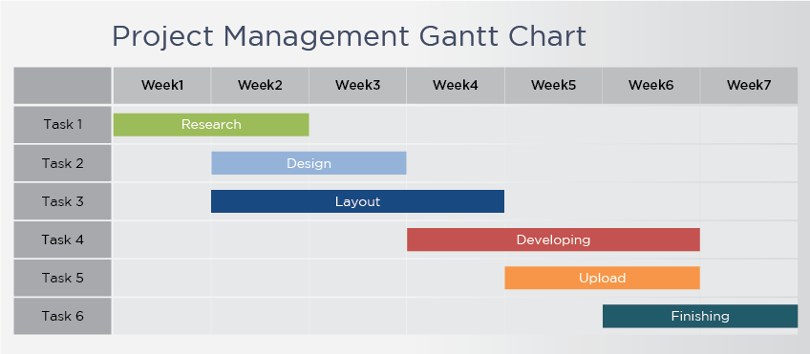
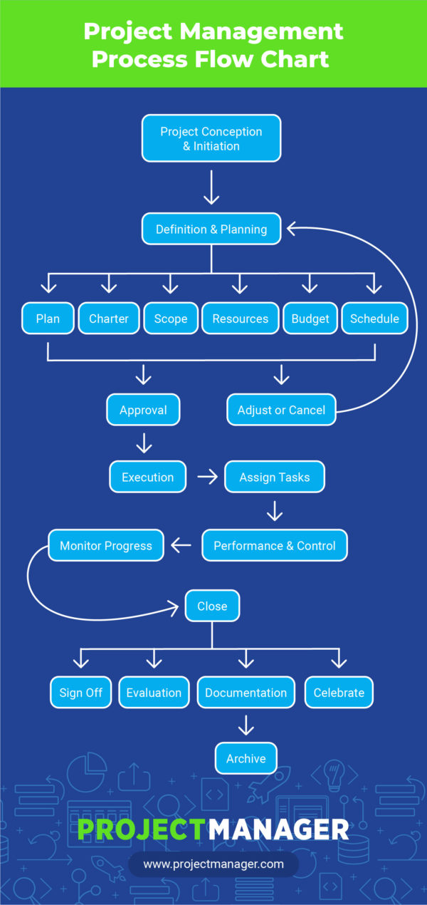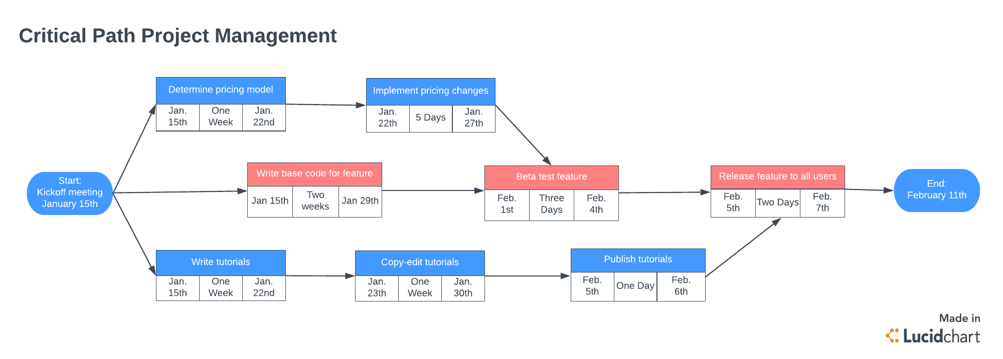

Qn2
Gantt chart is a vital timeline that shows the way to create a project to show the progress of the project during the management process. It helps project leaders to determine the duration of the process and helps them plan on the resources needed and the time to deliver the project (Gantt and Adamiecki, 2015, pp118).
The flow chat is used to formulate the understanding of the process to be followed. It is also used to start the process of improvements in a project. It is used for planning by the project managers to study the flow of the ongoing process.
The Critical Path Analysis is used to reduce the hazards and cost of the complex project; it's a tool used for planning. Gives the project team leaders an overview of the project.
QN3
The theory of management is a group of practices used by the companies to increase the efficiency in output. It deals with the controlling production process and business functions accurately. This theory comprises of the strategies companies used by the company to boost efficacy in its tasks of production and production. The application of this theory enables the companies to use the least amount of inputs and maximizes production to increase income generations in forms of profits. This theory allows for optimizing of raw materials, labour and power to enable turning off these materials into goods and services (Nawaz and Khan, 2016, pp6).
Tools like network diagrams are used by project management team leaders for planning. These tools work effectively under some assumptions, such as all the ongoing projects should be completed before the other projects are initiated. The direction of the arrow indicates the flow of the project. The other assumption is that the two dates have relationship to the time the project will be completed. The duration of the projects is obtained by calculation by comparing the early start and early finish.
Qn4
Lean is a procedural approach applied to reduce activities that are not valuable to the process. It focuses on elimination of wasteful steps in the process and only considering those that are valuable. It ensures there is high quality and consumer satisfaction.
Six sigma is a data problem-solving method. Its focus is only the process variations on customer satisfaction. Its process is to ensure there is an active process.
Qn5
Lean and Six Sigma have a goal of implementing a process that improves the coordinated established principles and activities which promotes more substantial efficiency and effectiveness, with smaller wasteful activities (Asrar-ul-Haq and Kuchinke, 2016, pp59). This reflects the purpose of continuous reduction in waste and improving workflow to produce a service that is believed to be of high quality to consumers.
Qn6
The management process of our organization the automotive industry in has set means of formulating goals, planning and controlling the operation of the organization. The senior management team is to ensure there is smooth running of the organization to ensure there is excellent communication between the employees and the implementation of the set targets to ensure the organization if generating more profits (Arnold, et al., 2016, pp481).
I recommend that the organization to use transactional leadership in its operation and to keep rewarding those who have work to ensure the sustainability of the organization.

References
Arnold, K.A., Connelly, C.E., Walsh, M.M. and Martin Ginis, K.A., 2015. Leadership styles, emotion regulation, and burnout. Journal of Occupational Health Psychology, 20(4), p.481.
Asrar-ul-Haq, M. and Kuchinke, K.P., 2016. Impact of leadership styles on employees’ attitude towards their leader and performance: Empirical evidence from Pakistani banks. Future Business Journal, 2(1), pp.54-64.
Gantt, H. and Adamiecki, K., 2015. Gantt chart.
Holten, A.L. and Brenner, S.O., 2015. Leadership style and the process of organizational change. Leadership & Organization Development Journal, 36(1), pp.2-16.
Kerzner, H., 2017. Project management: a systems approach to planning, scheduling, and controlling. John Wiley & Sons.
Nawaz, Z.A.K.D.A. and Khan_ PhD, I., 2016. Leadership theories and styles: A literature review. Leadership, 16, pp.1-7.
Peker, S., Inandi, Y. and Giliç, F., 2018. The Relationship between Leadership Styles (Autocratic and Democratic) of School Administrators and the Mobbing Teachers Suffer. European Journal of Contemporary Education, 7(1), pp.150-164.
Wellman, E.M. and LePine, J., 2017. Laissez-Faire leadership and informal leadership behavior. In Academy of Management Proceedings (Vol. 2017, No. 1, p. 11499). Briarcliff Manor, NY 10510: Academy of Management.

